Our Puppies
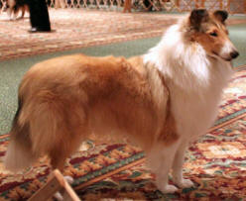& 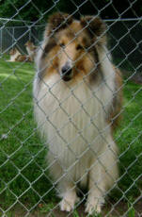
Sanshor Goldust O'Washoe & Ch. Concord the Franchise
A Litter of six (6) puppies were born on 6-5-2012.
2 males-Sable & white; 2 Females Sable & white and 2 Females tri-headed Whites.
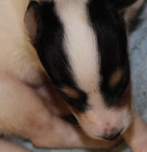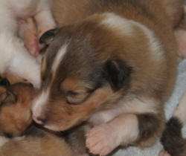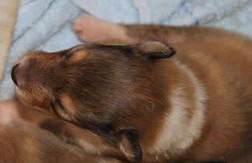
Pedigree for Litter
Collie/ Rough/Sable & white
Sire  Ch. Concord the Franchise | Sire  Ch. Donneybrooke's Mallorica | Sire  Ch. Windhaven Stranger in Paradise
Sire  Ch. Concord the Franchise | Sire  Ch. Donneybrooke's Mallorica | Dam  Donneybrooke's Cowgirl Up
Sire  Ch. Concord the Franchise | Dam  Karavel Diamond in the Ruff | Sire  Ch. Afterhours Southern Knight
Sire  Ch. Concord the Franchise | Dam  Karavel Diamond in the Ruff | Dam  Ch. Karvel Afterhours Amulet
Dam  Sanshor Goldust O'Washoe | Sire  Milas Sierra Avalanche of Washoe | Sire  Ch. Milas Latin Fever
Dam  Sanshor Goldust O'Washoe | Sire  Milas Sierra Avalanche of Washoe | Dam  Milas Scarborough First Seen
Dam  Sanshor Goldust O'Washoe | Dam  Washoe's Black Dahila of Concord | Sire  Ch. Clarion the Metropolitan
Dam  Sanshor Goldust O'Washoe | Dam  Washoe's Black Dahila of Concord | Dam  Concord Three in One

