Sanshor Goldust O'Washoe
"Lexi"
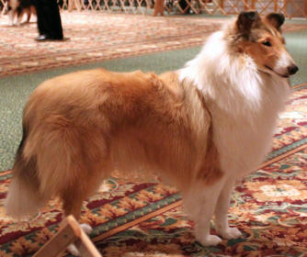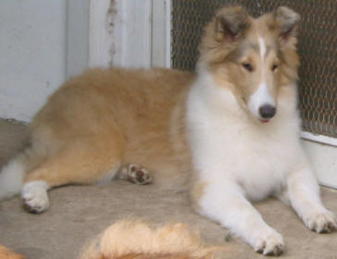
Pedigree for Lexi
Rough Collie
Sire  Milas Serria Avalanche of Washoe | Sire  Ch. Milas Latin Fever | Sire  Ch. Windhaven Stranger in Paradise | Sire  Windhaven Old Fashion
Sire  Milas Serria Avalanche of Washoe | Sire  Ch. Milas Latin Fever | Sire  Ch. Windhaven Stranger in Paradise | Dam  Windhaven Unchain my heart
Sire  Milas Serria Avalanche of Washoe | Sire  Ch. Milas Latin Fever | Dam  Lakewinds Dancestep of Milas | Sire  Ch. Gambit's A Hurricane Brew'n
Sire  Milas Serria Avalanche of Washoe | Sire  Ch. Milas Latin Fever | Dam  Lakewinds Dancestep of Milas | Dam  Lakewinds Riverdance
Sire  Milas Serria Avalanche of Washoe | Dam  Milas Scarborough First Seen | Sire  Hi-Crest Infiniti | Sire  Ch. Clarion Incognito
Sire  Milas Serria Avalanche of Washoe | Dam  Milas Scarborough First Seen | Sire  Hi-Crest Infiniti | Dam  Ch. Hi-Crest Ultraviolet
Sire  Milas Serria Avalanche of Washoe | Dam  Milas Scarborough First Seen | Dam  Scarbroughs Etched in Lace | Sire  Ch. Walters Jomar Cave Dweller
Sire  Milas Serria Avalanche of Washoe | Dam  Milas Scarborough First Seen | Dam  Scarbroughs Etched in Lace | Dam  Scarborough After the Gold
Dam  Washoe's Black Dahlia of Concord | Sire  Ch. Clarion the Metropolitan | Sire  Ch. Clarion Incognito | Sire  Ch. Gambit's A Hurricane Brew'n
Dam  Washoe's Black Dahlia of Concord | Sire  Ch. Clarion the Metropolitan | Sire  Ch. Clarion Incognito | Dam  Clarion Brilliant Disguise
Dam  Washoe's Black Dahlia of Concord | Sire  Ch. Clarion the Metropolitan | Dam  Ch. Clarion HiCrest Violet Vixen | Sire  Clarion World Class
Dam  Washoe's Black Dahlia of Concord | Sire  Ch. Clarion the Metropolitan | Dam  Ch. Clarion HiCrest Violet Vixen | Dam  Ch. Hi-Crest Ultraviolet
Dam  Washoe's Black Dahlia of Concord | Dam  Concord Three in one | Sire  Ch. Clarion Smoke & Mirrors | Sire  Ch. Clarion Incognito
Dam  Washoe's Black Dahlia of Concord | Dam  Concord Three in one | Sire  Ch. Clarion Smoke & Mirrors | Dam  Ch. Clarion Frost on the Meadows
Dam  Washoe's Black Dahlia of Concord | Dam  Concord Three in one | Dam  Clarion Souther Storm | Sire  Clarion Alenclaud Alliance
Dam  Washoe's Black Dahlia of Concord | Dam  Concord Three in one | Dam  Clarion Souther Storm | Dam  Clarion Masquerade

