Sanshor Dancing in the Sky
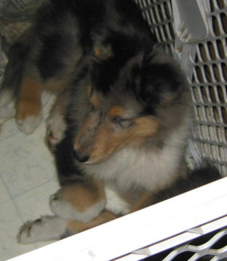
Pedigree for Sanshor Dancing in the Sky
Sire  Ch. Winover Shadow's in the Sky | Sire  Ch. Tartanside Winover Warlock | Sire  Ch. Tartanside Select | Sire  Ch. Tartanside Illumination
Sire  Ch. Winover Shadow's in the Sky | Sire  Ch. Tartanside Winover Warlock | Sire  Ch. Tartanside Select | Dam  Ch. West River's Starry Starry Night
Sire  Ch. Winover Shadow's in the Sky | Sire  Ch. Tartanside Winover Warlock | Dam  Tartanside Radiant | Sire  Ch. Tartanside Raptorvale Rebel
Sire  Ch. Winover Shadow's in the Sky | Sire  Ch. Tartanside Winover Warlock | Dam  Tartanside Radiant | Dam  Ch. Tartanside Ravishing
Sire  Ch. Winover Shadow's in the Sky | Dam  West River's Watercolor | Sire  Ch. West River's Winchester | Sire  Ch. Starr's Tailor Made
Sire  Ch. Winover Shadow's in the Sky | Dam  West River's Watercolor | Sire  Ch. West River's Winchester | Dam  Wayside Sumer Breeze
Sire  Ch. Winover Shadow's in the Sky | Dam  West River's Watercolor | Dam  Tartanside Painted Lady | Sire  Ch. Tartanside Illumination
Sire  Ch. Winover Shadow's in the Sky | Dam  West River's Watercolor | Dam  Tartanside Painted Lady | Dam  Ch. West River's Starry Starry Night
Dam  Deep River Sanshor Show Girl | Sire  Ch. Deep River's Shadow of Victory | Sire  Ch. Pinewynd's Sparkling Brut | Sire  Ch. Collairine's Convoy O'Pinewynd
Dam  Deep River Sanshor Show Girl | Sire  Ch. Deep River's Shadow of Victory | Sire  Ch. Pinewynd's Sparkling Brut | Dam  Pinewynd's Oreo Deluxe
Dam  Deep River Sanshor Show Girl | Sire  Ch. Deep River's Shadow of Victory | Dam  Deep River Soley Opening Night | Sire  Ch. Sho Me the Way
Dam  Deep River Sanshor Show Girl | Sire  Ch. Deep River's Shadow of Victory | Dam  Deep River Soley Opening Night | Dam  Deep River Night 'N White Satin
Dam  Deep River Sanshor Show Girl | Dam  Ch. Deep River Westwood Glamor Girl | Sire  Ch. Tartanside Power Play | Sire  Ch. Tartanside Dauntless
Dam  Deep River Sanshor Show Girl | Dam  Ch. Deep River Westwood Glamor Girl | Sire  Ch. Tartanside Power Play | Dam  Ch. Tartanside Foolproof
Dam  Deep River Sanshor Show Girl | Dam  Ch. Deep River Westwood Glamor Girl | Dam  Ch. Deep River Karizma Honey Bare | Sire  Ch. Pinewynd's Sparkling Brut
Dam  Deep River Sanshor Show Girl | Dam  Ch. Deep River Westwood Glamor Girl | Dam  Ch. Deep River Karizma Honey Bare | Dam  Ch. Karizma Dressed to Kill

